Year 1 Home learning menu- week 1
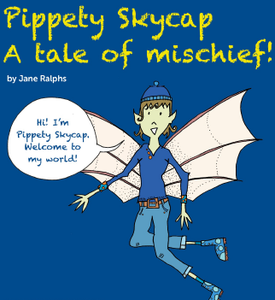 | Read and retell.  Read the story “Pippety Skycap- A Tale of Mischief.”- found at the bottom of the plan or listen to the story using the powerpoint. Make up actions to retell the story and help you learn it off by heart.  Can you retell the story to someone in your house? | Opinion  Listen to and retell the story again. Did you like it? What did you like? Write sentences starting:  I liked…  I want to know…  I was surprised by… | Draw  Retell the story again.  Can you draw a text map for the story?  I have shared the start of mine.  Why not magpie from that? | Write  Retell the story again, following your story map.  Draw each of the characters from the story, giving them each a speech bubble. What important thing did they say? | Quiz  Answer the questions:  - Where does Pippety Skycap live?  - What does Pippety Skycap like to do?  - What happened to the troll, cat and the toad?  - What did the King Toad do to Pippety?  - Do you think Pippety will be a good pixie from now on? How do you know?
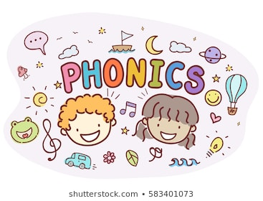 | Play Alien Escape on phonicsbloom.com. Select phase 3, phase 4 or phase 5. | Play Obb and Bob on phonicsplay.co.uk- choose your own grapheme from phase 3. | Sing the vowel song.  https://www.youtube.com/watch?v=arQxkdRYyE4 | Play tricky word trucks on phonicsplay.co.uk.  Work your way up from phase 2. | Read the Non-Statutory Example Words for Year 1 that can be found on the Y1 page of our school website. How many can you read? How many can you spell?
RE |   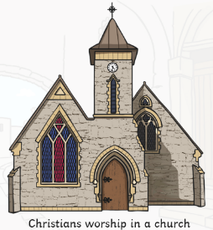  As Christians at St Paul’s we worship in a church.  Can you investigate, with help of your adult, where people of other faiths worship?  What are the similarities and differences?  Have you ever seen other places of worship?  When Jesus was a boy, he was a Jew. He worshipped in a Temple or Synagogue.  Draw a picture of a Synagogue and label any important parts.
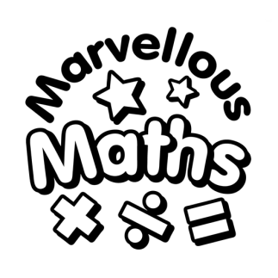 | Find and make number bonds  Can you find all the different numbers that total 10?  You could use pasta or cubes to helps you.  Write all the calculations out- making sure all your digits are the right way round.  Are you sure you have them all?  How do you know? | Fact Families- linking addition to subtraction  Using the additions to 10 you created yesterday, can you now write some subtractions?  For example-  I know that  7 + 3 = 10  Which means I also know that 3 + 7 = 10  And  10 – 7 = 3  Can you see the pattern? | Add together and find a part  I challenge you to write a calculation that will total every number from 1-10!  1+0=1  1+1=2  2+1=3  Etc  Is there a pattern?  Extra challenge:  - Hide a number in some of you calculations- can you say which number is missing? | Solve problems within 10  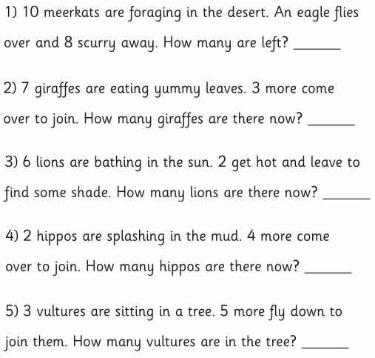
See the materials challenge power point for more fun activities.

