Personal and Social Development  Self-Regulation:  ● I can talk about my feelings I can understand the feelings of others.  ● I can follow basic instructions and the “rules” of the setting.  ● I can choose what I need to complete a goal (short term)  Managing Self:  ● I am starting to handle new experiences with more confidence.  ● I can toilet myself.  Building Relationships:  ● I can play with others cooperatively.  ● I can use appropriate ways of being assertive when needed.  Physical Development  Gross Motor  ● I can skip, hop and stand on one leg  ● I can remember patterns of movement related to music/rhythm.  ● I can develop movement and balance (using age appropriate bikes, scooters etc.)  ● I can work with others to manage large items  Fine Motor  ● I can eat using a knife and fork.  ● I can manage zips, putting on coats etc.  ● I can demonstrate good fine motor control when using tools e.g. scissors.  ● I show a preference for a dominant hand with a comfortable pencil grip  ● I can draw a picture.  Health and Hygiene  ● I can use the toilet independently and know to wash my hands.  ● I can make healthy choices.  Understanding the World  Past and Present  ● I can talk about the different jobs people do  ● I can name some members of my family and talk about them  ● I can talk about myself and some of the ways I have changed.  People Culture and Communities  ● I can explore the world around me with all my senses  ● I can be accepting and positive about people’s differences  ● I know there are different countries in the world  The Natural World  ● I can talk about what I can see outside using a wide vocabulary  ● I enjoy playing with and exploring different materials e.g. adding water to cornflour, mixing paint etc. | Reception  Autumn Term 1: Topic 1: My Fabulous Feelings  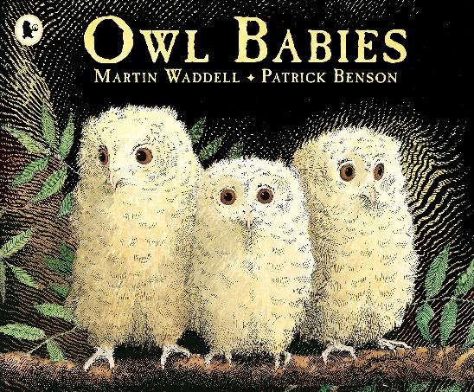  RE: Creation and Covenant.  The words and actions of the Sign of the Cross. God created the world and said, ‘Indeed it is very good’. (Genesis 1:31) The whole of creation shows God’s love for us. (Laudato Si’ 84-88)  God is love. God made each one of us. God loves each one of us as a unique person. God made a wonderful world and what God creates is good. God loves us and we are part of a family. Catholic Social Teaching God made: the earth and sky, all the people all over the world, all the animals and plants, the air, the ground and the water.  Mathematics  Number  ● I can show numbers to 5 using concrete resources  ● I can match numeral and quantity to 5  ● I can say one number name for each item  ● I can quickly say how many there are (up to 3)  ● I can solve some simple problems with numbers to 5  Numerical Patterns (and Shape)  ● I can count to 5 reliably  ● I can start to count beyond 5  ● I am starting to compare quantities using non-standard vocabulary  ● I can start to continue and copy patterns  ● I can talk about 2D & 3D shapes using informal and some mathematical language | Communication and Language  Listening Attention and Understanding  ● I can follow a one or two part instruction  ● I enjoy joining in at group times and story times  ● I can talk to others and take it in turns to speak  Speaking  ● I can express a point of view  ● I can use talk to share what I think  ● I can use a sentence of 4-6 words  ● I can use speech as a way of starting to express myself  Literacy  Writing  ● I can write some letters from my name  ● I can orally segment single sound CVC words  e.g. c-a-t  ● I can say the initial sounds in most words  ● I can write some initial sounds  ● I can write my own name  Comprehension  ● I can talk about stories I have heard  ● I can guess what might happen next  ● I can join in with familiar rhymes and songs (and some patterned stories)  Word Reading  ● I can hear and say initial sounds for words  ● I can say the sound for some letters (e.g. from my name or familiar names- Mum, Dad, etc.)  ● I can orally blend words (e.g. adult says m-a-n and child says man)  Expressive Arts and Design  Creating with Materials  ● I can start to join materials together  ● I can explore art materials and colour mixing freely  ● I can develop my own ideas for art  ● I can develop my own ideas for art and start to talk about them (with adult support)  Being Imaginative and Expressive.  ● I can start to develop my own imaginative stories linked to what I know through role & small world play  ● I can remember most of a song to sing and make up my own songs  ● I can start to match the melody and pitch of others.

