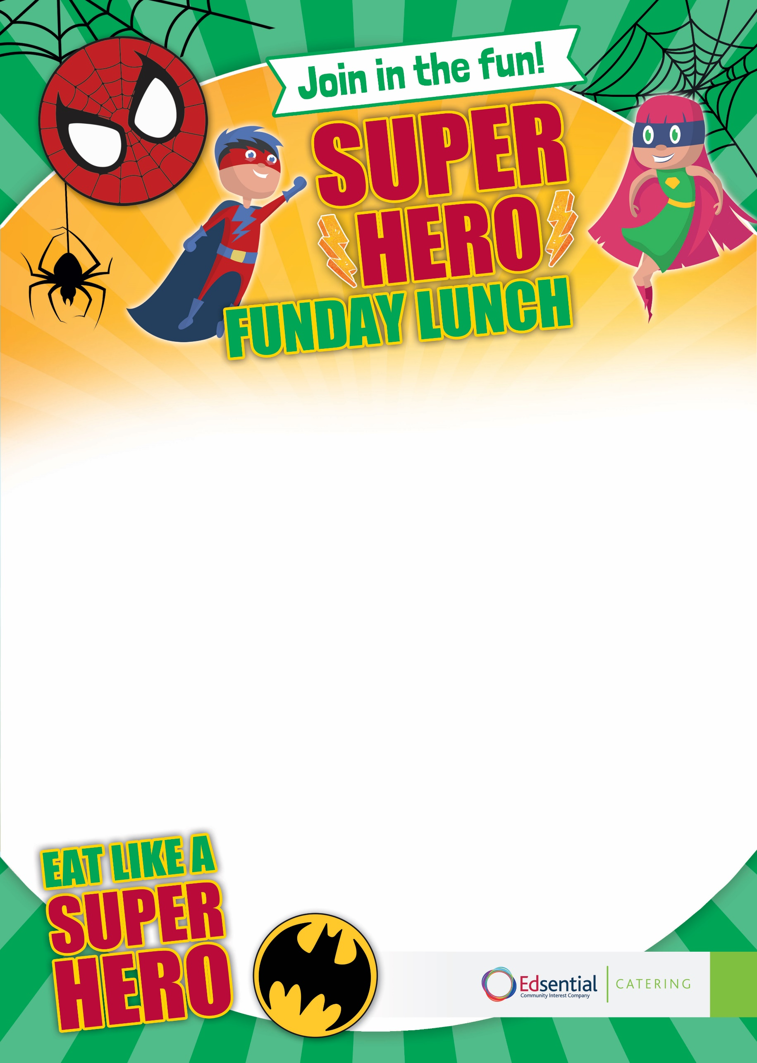
Hulk Cake
Fresh Fruit Platter
Vegetarian options available
Joker’s Jacket Potato Selection Served with Various Fillings and a Mixed Salad

Marvel’s Meatball Pitta Pocket (Build Your Own) Served with Superman’s Ziggy Fries and Magneto Mixed Salad
Thursday 21st May 2026

