

St Wilfrid’s snow day indoor activity grid (Reception)

Phonics/Writing | Maths | RE/Prayer
Can you write a sentence to match the picture? (separate worksheet). Practice all phonemes and harder to read words.  Write a sentence using your phonics, e.g.: The man has a cat.  The bug is red. | Complete the maths challenge.  Shape powerpont – guess the 2D shape (resource separate)  Colour 2D shapes sheet (resource separate)  Counting activity (resource separate)  Numbots. Logins in reading diary. | 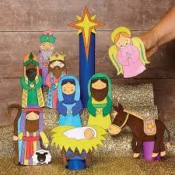  Ask the children about the story of the Nativity up until the shepherds arrive. (If possible read the story together). Do they remember the part they played in our nativity? Can they draw a picture of the stable including all the characters?
Understanding the World. | Art/craft | PE
Can you find signs of winter?    Play I spy. What can you see? Photograph or draw what you can see. | Draw a winter picture.  https://www.youtube.com/watch?v=sqDPtfWz5o8  Make a snowflake. Fold and cut.  https://www.youtube.com/watch?v=U32IwBAh1OU | https://www.youtube.com/watch?app=desktop&v=aW_JqSKCgY&t=71s  How many can you do in 1 minute:  Star jumps  Hops  Press ups  Run on the spot  Write your name  Catch a soft ball  Sit down/stand up

St Wilfrid’s snow day indoor activity grid (Reception)

