Online Safety Newsletter

May 2026

FreezeNova (Unblocked games)

FreezeNova unblocked is a website that is free to access and contains a wide variety of games, including shooting, multiplayer and racing games. This site may bypass usual filters, making it easier for your child to access games that you may not want them to play. As there are a variety of games, not all games may be suitable for your child.

There is also FreezeNova Chat, allowing users to chat to their friends and meet new ones. Clearly there are concerns with any online chat facility as there is the potential to view inappropriate content, risk of bullying as well as grooming.

We could not locate any age ratings on this site and there are constant adverts. Childnet have a webpage providing advice on gaming and chat features here:

https://www.childnet.com/help-and-advice/gaming/

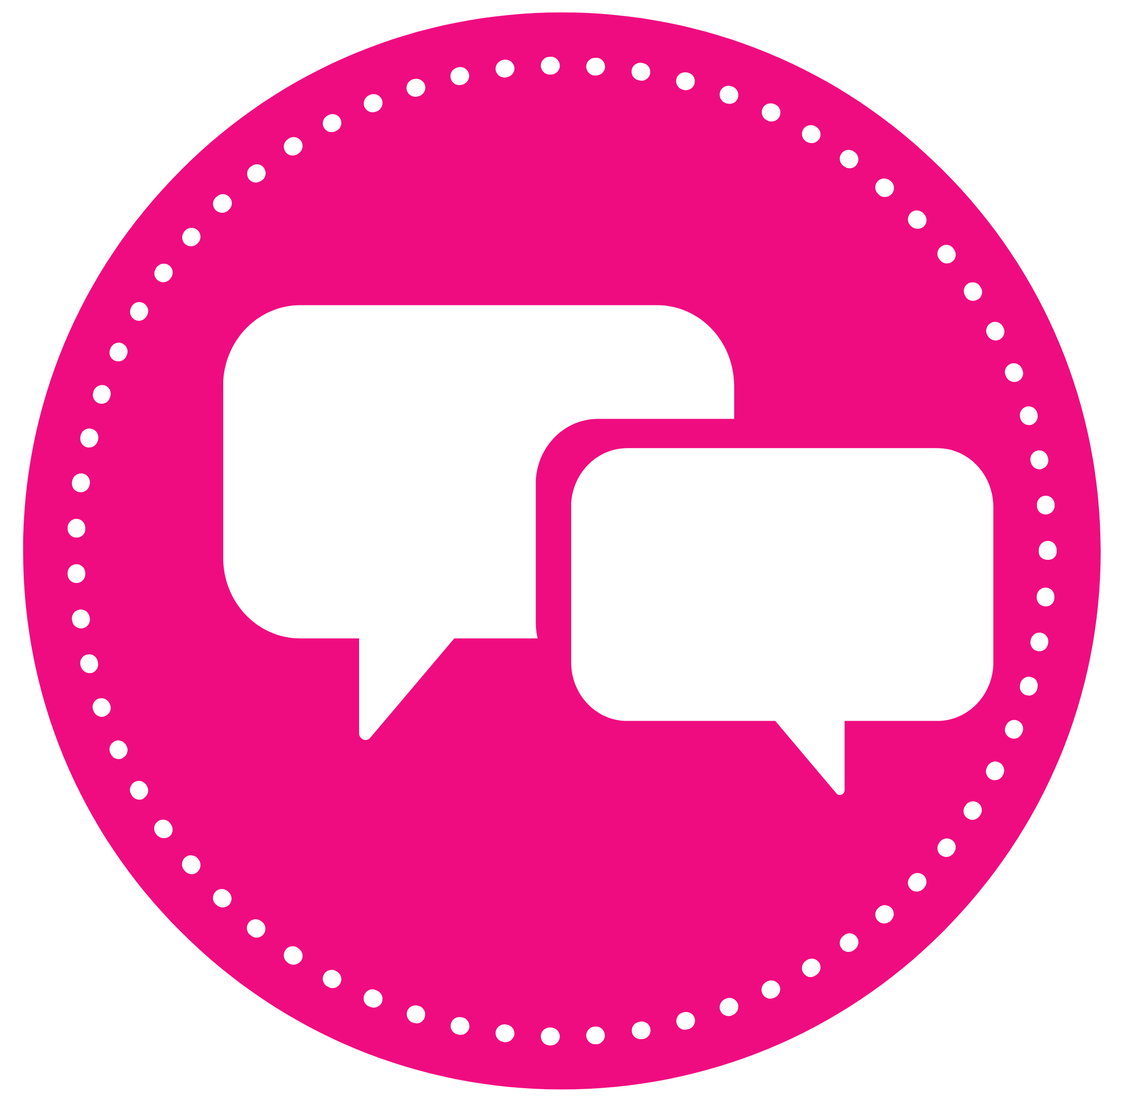
Group Chats
Is your child part of any group chats? This could be on social media, for example on WhatsApp or within games such as Fortnite. If so, it is important that you are aware of the potential risks, which include:
- Inappropriate content – there is often a lack of moderation within chat facilities so users could be exposed to content/language that is not suitable for their age.
- Bullying – there are many instances where inappropriate/hurtful comments are shared within groups, this could take the form of name calling or body shaming. Bullying can also be in the form of excluding others from the group. These issues often overspill into ‘real life’.
- Strangers – your child could be added to groups with people they do not know or even with someone that they have previously blocked.
- Conversations can be shared/screen shot – make sure your child is aware that anything they share within a group can be shared with others.
- Sharing personal information – remind your child to be aware of the information they share with others, including images and location.

How can I help make group chats safer?
- Check the recommended age rating and adhere to them.
- Set up age-appropriate parental controls, suitable privacy settings and set screen time limits.
- On WhatsApp you can do a privacy check, by going to settings, privacy and privacy checkup.
- Show your child how to use any reporting and blocking tools.

What else can I do?
- It is crucial to have regular conversations with your child about the risks outlined above and about what they are doing online.
- Talk about who they are chatting with, encourage them to think carefully about what they send and how it could be perceived by others. Talk about positivity and not saying anything hurtful. Ask them to think about whether they would say what they are messaging, face to face.
Would you like to read this newsletter in a different language? You can use the translate tool on our web version: https://www.knowsleyclcs.org.uk/may-2026-primary/
- Devices should be used in family rooms so you can monitor what they are doing and who they are interacting with.
- Finally, make sure to model good digital behaviour yourself, as children often learn by observing the adults around them.

Further information
https://www.nspcc.org.uk/keeping-children-safe/online-safety/social-media/chat-apps/

Screen time guidance for under 5s

The Government now advise limiting screen time for young children. They advise avoiding screen time for under 2 years and to try to keep it to less than 1 hour a day for 2-5 years. Best Start for Life have published an article outlining what content is better, how your own screentime affects your child and how screentime can affect your child’s development. Find out more here:

https://beststartinlife.gov.uk/screen-time-under-5s/

Roblox - update

What is Roblox?
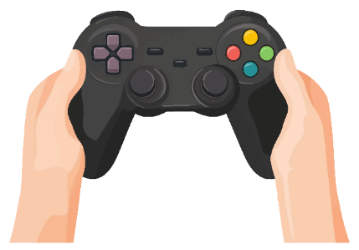
Roblox is a platform consisting of a collection of games. Players can either create games or play games that other users have created. As a lot of the content is user generated, not all games will be suitable for your child to view/play. If your child is playing Roblox, it is important to monitor what your child is accessing as well as set up appropriate parental controls. PEGI rate Roblox with a Parental Guidance recommended label, this is because it is a platform of individual, user generated games.

Do you know what ‘looksmaxxing’ is?

It is the idea of improving and maximising your looks. Internet Matters have published this article, which provides more information on this topic and outlines the risks (including links to the manosphere):

https://www.internetmatters.org/hub/news-blogs/what-is-looksmaxxing-online-safety-guidance-for-parents/

New Age-Based Accounts
From next month, Roblox will introduce two new age-based accounts: Roblox Kids for users ages 5 to 8 and Roblox Select for users ages 9 to 15. Roblox Kids Accounts (ages 5–8) will be limited to games with a ‘Minimal or Mild’ content maturity label and all communication is disabled by default. Roblox Select accounts (ages 9 to 15) will be limited to games with content maturity labels up to and including ‘Moderate’. By default, Experience Chat is ON and Direct Experience Chat is OFF. The differences in chat are outlined here: https://about.roblox.com/safety-by-age

Parental Controls
As part of parental controls, you can manage content ratings, communication, screen-time, and spending limits as well as see which games your child is playing on and who their friends are. Roblox are extending these controls to allow you to:
PEGI is expanding their age ratings

From June, PEGI is adding new categories. “Newly submitted games will be classified with a broader set of criteria that will focus on content and functionality, such as purchases of in-game content, paid random items, communication features, and features that incentivise players to continue playing.” Find out more here:

https://pegi.info/news/pegi-expands-age-rating-criteria-interactive-risk-categories

- Block specific individual games (to age 15).
- Manage direct chat settings (to age 15).
- Approve access to specific games.

It is important to regularly monitor what your child is playing on Roblox and who they are interacting with, even if you have parental controls set up. You can find out more about the new accounts and parental controls here:
https://about.roblox.com/newsroom/2026/04/introducing-roblox-kids-and-select-accounts

Further information
https://swgfl.org.uk/magazine/roblox-releases-updated-parental-controls-and-age-appropriate-experiences/

Users of this guide do so at their own discretion. No liability is entered into. Current as of the date released 01.05.26. The inclusion of any links does not imply any affiliation with or endorsement of the linked websites, documents, or videos, nor are we claiming any ownership or copyright in the content of the linked materials.

