**Malpas Alport Endowed Primary School**

|  |  |
| --- | --- |
| **Class Name:** Hazel, Birch and Maple | **Year groups:** Key Stage One (Y1 and 2) |

|  |  |  |
| --- | --- | --- |
| **Teaching Team around your child** | | |
|  |  |  |
| **Mr Palmer**  Maple Class Teacher  Key Stage One Leader | **Miss Lloyd**  Hazel Class teacher | **Miss Williams**  Birch Class Teacher |
|  |  |  |
| **Miss Whyte**  Higher Level Teaching Assistant | **Mrs Cooklin**  Specialist Support |  |

|  |
| --- |
| **Useful things to bring each day:** |
| * Water bottle (named and full with water only) * Small healthy afternoon snack apart from on Fridays which is treat day! * Waterproof Coat * School book bag with all school books and resources |

|  |
| --- |
| **PE days (school kit to be worn):**  Wednesday and Fridays.  Swimming information to follow. |

|  |
| --- |
| **Contact email for class team:** [hazel@malpasalportpri.cheshire.sch.uk](mailto:hazel@malpasalportpri.cheshire.sch.uk)  [birch@malpasalportpri.cheshire.sch.uk](mailto:birch@malpasalportpri.cheshire.sch.uk)  [maple@malpasalportpri.cheshire.sch.uk](mailto:maple@malpasalportpri.cheshire.sch.uk) |

|  |
| --- |
| **Homework/ Reading/ Spellings/ Times Table Expectations:**  **Spellings:**  This year, we will be moving away from weekly spelling lists and tests. Research suggests that the vast majority of pupils do not benefit from weekly spelling tests as they do not transfer their knowledge used in tests to their writing. At home, we would like you encourage your child to read and write words from the HFW/CVC/First 100/Next 200 spelling lists. We suggest focusing on between 5 and 10 words each week.  **Reading Record Planners:**  These planners are to be used by staff and parents to keep a log of every time your child reads. It is now presented on a weekly view with the expectation that your child reads daily. This will really benefit your child and they will also receive a variety of rewards for striving to read at least 5 times a week. This will be regularly checked and prizes will be awarded to those children striving for 5 each week. Children are read with daily during their phonics sessions which will not be recorded in reading records but a teacher log will be kept.  **Reading – Phonics Books:**  The children will bring a book(s) home each week to read with you at home. The numbers and colours relate to what level of reading that they are working on which will link to their phonics groups. The children will have read one of their books in class during their phonics lessons that week and will take home another book to support their learning further. The idea is that these books are read again to increase pace, fluency and the familiarity of those keywords for that week through repetition. They will need to bring their phonics books back every **Thursday** to be replaced.  **Reading – Beautiful Books:**  The children will bring a beautiful book home each week to either read to you (if they can) or to have it read to them with a special grown up or older sibling. This is to extend their experience of a variety of book genres and explore different texts. They will need to bring their phonics books back every **Friday** to be replaced.  **Homework:**  Homework for Year 1 and 2 is set termly and focuses on creative choice activities. Children are welcome to bring in their creations or email them to the class teacher at any point during the term. Please note that this homework is optional for Key Stage 1.  **Oxford Owls:**  You will receive a class login for this shortly. Please login each week to read stories online with your child. We will use this platform to set books that link to their phonics learning for that week so it is really beneficial for your child to access this. They also have the opportunity to explore and read books on Oxford Owls at their own leisure. This can be accessed at [www.oxfordowl.co.uk](http://www.oxfordowl.co.uk)  **Numbots:**  We are pleased to introduce Numbots, an engaging online platform designed to help children develop and strengthen their maths skills through fun and interactive activities. We encourage you to support your child in using Numbots at home as part of their regular learning routine. You can access Numbots via the app or web browser. Your child will be provided with their own login details to get started.  **Timestable Rockstars:**  The children will all have a username and pin code to log in and practise their timetables on ‘Timestable Rockstars’ at their own leisure. We can track their scores and progress and this will help with their speed, recall and recognising the answers out of order. We can also move the children up through stages as their scores and speed improve. This method is to replace Maths Target Cards. A further replacement will be introduced once we have a new learning scheme in Maths set up in school by our Maths Coordinator. This can be accessed at [ttrockstars.com](https://ttrockstars.com/). This log in will also be the same as their Numbots log in.  Please ensure your child has all of their books/resources in their bag each day. |

|  |  |  |
| --- | --- | --- |
| **Main curriculum areas for the Autumn term- please see the attached curriculum sheet for more details** | | |
| **Reading:**  Developing phonic decoding skills.    **Writing:**  Composing sentences. | **Science:**  Living things and their habitats | **History:**  Yr 1 – My Family  Yr 2 – Bonfire Night and Great Fire of London  **Geography:**  Yr 1 – Our Local Area  Yr 2 – People and their communities |
| **Maths:**  Place Value  Addition and Subtraction Shape | **Art:**  Spirals | **PE:**  Multi-Skills    **Personal, Social, Health Education:**  Me & My Relationships |
| **Computing:**  Internet Safety | **Music:**  Hands, feet, heart | **RE:**  Christianity: Belonging |

**1-5 behaviour system:**

1. Above and beyond high expectations. Wow!
2. On task, working hard and meeting expectations.
3. Some reminders needed. Try to refocus and get back on track.
4. Time to think and remember our school promises. Too many reminders being given.
5. Consistent poor behaviour. Time for a chat and catch up at play time.

Children on a 1 will be recorded daily and weekly prizes, rewards and certificates are available.

Each session of the day resets so the children have the chance to start again.

Numbered visuals are only used to remind the children of each step.

Verbal praise and verbal reminders are given so that the children know where they are up to.

**We look forward to our year with all of the children and thank you in advance for your support.**

**Key Stage One Team.**

**This Year in Year 1:**

|  |  |
| --- | --- |
| **Autumn 1** | **Autumn 2** |
| Subjects:  Literacy (Year 1) – Quest, The Hungry Caterpillar  Maths – Numbers to 10  History – My Family  Geography – Our Local Area  Science – Animals including Humans  Art- Spirals  RE – Christianity: Belonging  Music – Hands, Feet Heart  ICT – Internet Safety  PE – Multi-Skills  PSHE – Me and my relationships | Subjects:  Literacy (Year 1) – Nibbles, Stickman  Maths – Shapes  History – My Family  Geography – Our Local Area  Science - Animals including Humans  RE – Christianity – Celebrating Christmas  Music – Christmas Nativity  ICT – Exploring Purple Mash  PE – Cricket  PSHE – Valuing Difference  DT – Create a Great British Picnic |
| **Spring 1** | **Spring 2** |
| Subjects:  Literacy (Year 1) – The most important animal of all  Maths - Numbers to 20  Geography – Seasons  History- My School  Science - Materials  Art- Simple print making  RE – World Views - How the world was made.  Music – Rhythm in The Way We Walk and Banana Rap  ICT – Maze Explorers  PE - Gymnastics  PSHE – Keeping Safe | Subjects:  Literacy (Year 1) – Toys in space, Beegu  Maths – Length and Height  History- My School  Geography – Seasons  Science - Materials  DT- Crete a Toy Soldier with outfit.  RE – Why is light used in Religion?  Music – I Wanna Play in a Band  ICT - Pictograms  PE - Dance  PSHE – Rights and Respects |
| **Summer 1** | **Summer 2** |
| Subjects:  Literacy (Year 1) – Return, Paddington  Maths – Multiplication and Division  Geography – Animals and their Habitats  History – Our Local Heroes  Science – Plants  Art- Sculpture making  RE - Islam: Allah & Muhammed  Music – Round and Round  ICT – Making Music  PE - Football  PSHE – Being My Best | Subjects:  Literacy (Year 1) – The Lion Inside  Maths - Time  History – Our Local Heroes  Geography - Animals and their Habitats  Science - Plants  DT – Design & make a tower with a lever  RE – Islam: New Beginnings  Music – Reflect, Rewind & Replay  ICT – Presenting Ideas  PE – Sports Day Skills  PSHE – Growing & Changing |

**This year in Year 2:**

|  |  |
| --- | --- |
| **Autumn 1** | **Autumn 2** |
| Subjects:  Literacy (Year 2) – Quest, The owl afraid of the dark.  Maths – Place Value  History – Bonfire Night and the Great Fire of London.  Geography – People and their communities  Science – Animals including Humans  Art- Spirals  RE – Christianity: Belonging  Music – Hands, Feet Heart  ICT – Internet Safety  PE – Multi-Skills  PSHE – Me and my relationships | Subjects:  Literacy (Year 2) – The days the crayons quit, The Grinch who stole Christmas.  Maths – The 4 Operations  History – Bonfire Night and the Great Fire of London.  Geography – People and their communities  Science - Animals including Humans  RE – Christianity – Celebrating Christmas  Music – Christmas Nativity  ICT – Exploring Purple Mash  PE – Cricket  PSHE – Valuing Difference  DT – Create a Great British Picnic |
| **Spring 1** | **Spring 2** |
| Subjects:  Literacy (Year 2) – The last tree  Maths - Measurements  Geography – Journeys - Food  History- The Great Innovators  Science - Materials  Art- Simple print making  RE – World Views - How the world was made.  Music – Rhythm in The Way We Walk and Banana Rap  ICT – Maze Explorers  PE - Gymnastics  PSHE – Keeping Safe | Subjects:  Literacy (Year 2) – Dragon Machine, Lubna and Pebbie  Maths – Mass and Volume  History- The Great Innovators  Geography – Journeys - Food  Science - Materials  DT- Crete a Toy Soldier with outfit.  RE - Why is light used in Religion?  Music – I Wanna Play in a Band  ICT - Pictograms  PE - Dance  PSHE – Rights and Respects |
| **Summer 1** | **Summer 2** |
| Subjects:  Literacy (Year 2) – Return, The Last Wolf  Maths – Fractions and Money  Geography- Our Wonderful World  History – Great Inventions  Science – Plants  Art- Sculpture making  RE - Islam: Allah & Muhammed  Music – Round and Round  ICT – Making Music  PE - Football  PSHE – Being My Best | Subjects:  Literacy (Year 2) – Ravi’s Roar  Maths - Time  History – Great Inventions  Geography- Our Wonderful World  Science- Plants  DT – Design & make a tower with a lever  RE – Islam: New Beginnings  Music – Reflect, Rewind & Replay  ICT – Presenting Ideas  PE – Sports Day Skills  PSHE – Growing & Changing |

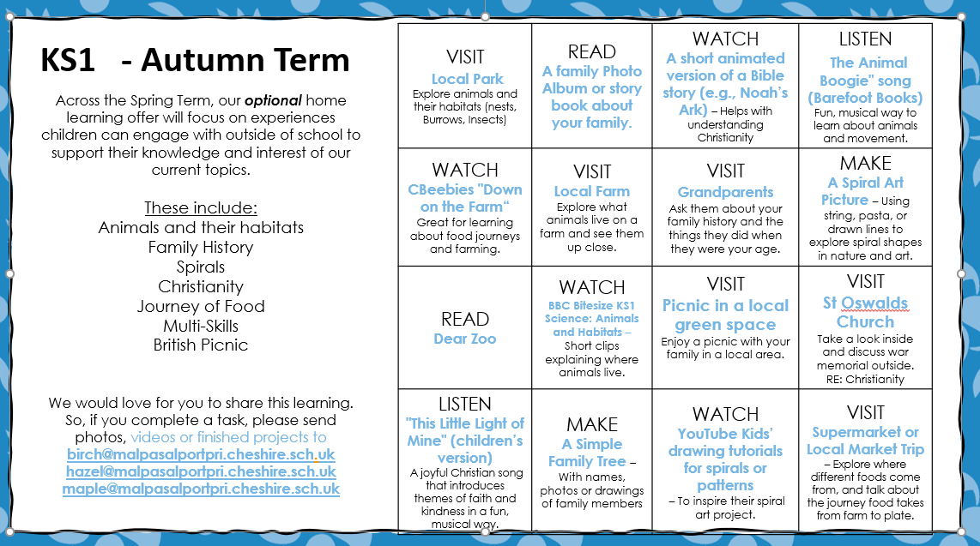

Autumn Term Creative Choice Homeworks