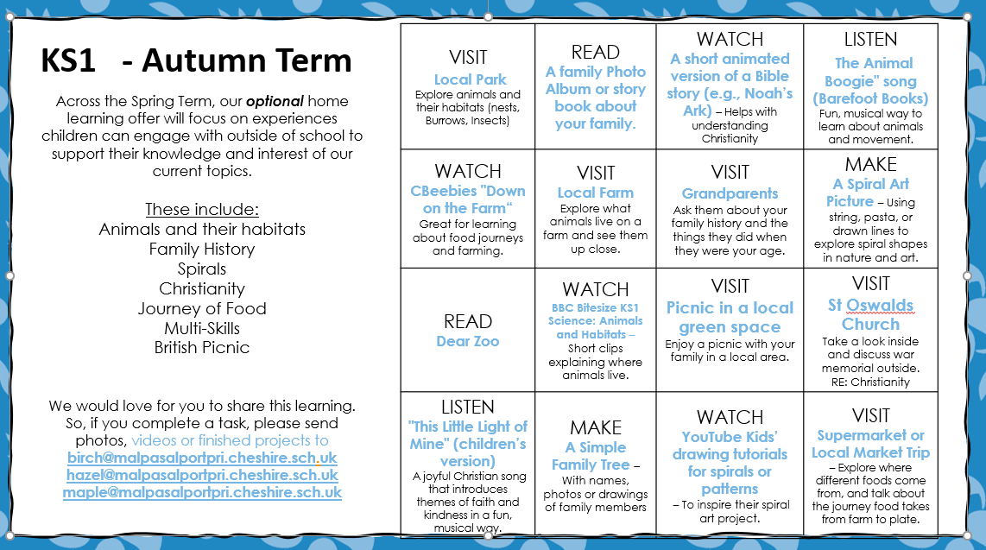

Autumn Term Creative Choice Homework